Design of Vacuum-Cleaning Robot for Debris Collection on Manufacturing Shop Floor
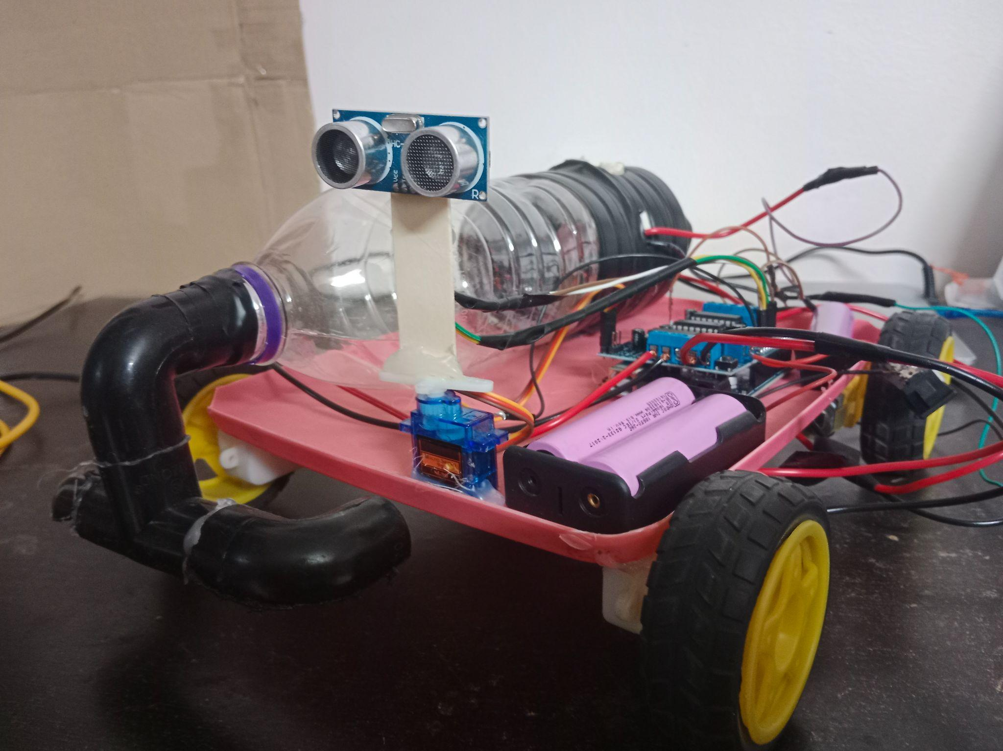

1. Introduction
A vacuum-cleaning robot is an autonomous mobile robot designed to clean floor surfaces without human intervention. It uses electric suction motors, brushes, sensors, and control algorithms to collect dust and debris. Navigation through indoor environments is achieved using obstacle-detection sensors and intelligent movement strategies. Benefits: reduces manual effort, saves time, and improves cleaning efficiency. With advances in robotics, IoT, and automation, robotic vacuum cleaners are becoming essential in smart homes and industries. This project focuses on designing a low-cost, intelligent vacuum-cleaning robot capable of proper navigation and effective debris collection.

2. Problem Statement
- Manual cleaning is time-consuming and physically tiring.
- Regular cleaning is difficult in large areas (homes, offices, workshops).
- Human cleaning may miss corners, under-furniture spaces, and narrow areas.
- Existing robotic vacuum cleaners are expensive and not affordable for everyone.
- Core problem: need for a cost-effective, efficient, and automated cleaning solution — designing an autonomous vacuum-cleaning robot that cleans efficiently with minimal human intervention and low cost.

3. Objectives
Main Objective: Design and develop a prototype of an autonomous vacuum-cleaning robot.
Specific Objectives:
- Design a compact and stable robot chassis.
- Integrate suction motor and brush mechanism for effective debris collection.
- Implement obstacle detection using sensors (Ultrasonic/IR).
- Program autonomous navigation using a microcontroller (Arduino/ESP32, etc.).
- Ensure efficient battery management and power control.
- Test and evaluate cleaning performance on different surfaces.

4. Mathematical Work
Component current draw (at 12V):
Component | Current
Gear Motor (×2, 12V) | 2 × 0.3 = 0.6 A
Arduino Uno (5V via LM7805) | 0.05 A
Arduino Motor Shield (L298P) | 0.07 A
Servo Motor (5V) | 0.15 A
Ultrasonic Sensor HC-SR04 (5V) | 0.015 A
6V Suction Motor (via LM7806) | 0.5 A
Total current: I_total = 0.6 + 0.05 + 0.07 + 0.15 + 0.015 + 0.5 = 1.385 A
Total power: P_total = V × I = 12 × 1.385 = 16.62 W
Battery (Li-ion, 3S1P):
- Pack voltage: 3 × 3.7 = 11.1 V ≈ 12 V
- Capacity: 2200 mAh (2.2 Ah)
- Energy: E = 11.1 × 2.2 = 24.42 Wh
- Run time: t = 24.42 / 16.62 ≈ 1.47 hours

5. Results
- "The system demonstrates effective low-cost autonomous cleaning using embedded control and sensors."
- Successfully performs autonomous navigation.
- Detects obstacles using an ultrasonic sensor and avoids collisions.
- Intelligently selects the best path (left/right) based on distance.
- Smooth forward/backward movement achieved using DC gear motors.
- Servo motor enables efficient environment scanning.
- Stable operation observed with a battery-powered system.
- Capable of basic floor cleaning with a suction mechanism.

6. Summary
The vacuum-cleaning robot is an autonomous system built using Arduino, DC motors, an ultrasonic sensor, and a servo motor. It moves forward while continuously detecting obstacles and avoids collisions by changing direction intelligently, using simple control logic and motor coordination for efficient navigation. Overall, it demonstrates a cost-effective and reliable solution for basic automated cleaning applications.

